QUESTION 1
Load a dataset using Python and perform basic data exploration. Identify number of rows, columns, data types, and summary statistics.
PROGRAM CODE
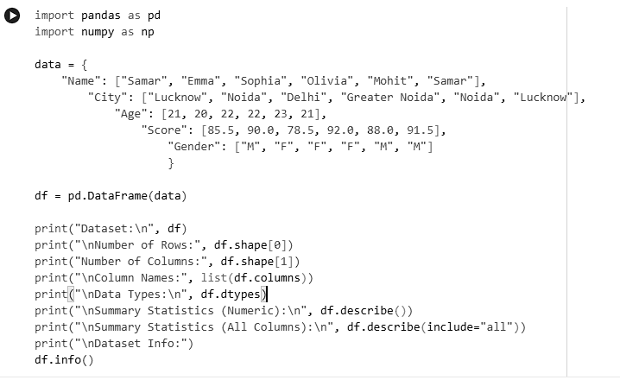
OUTPUT
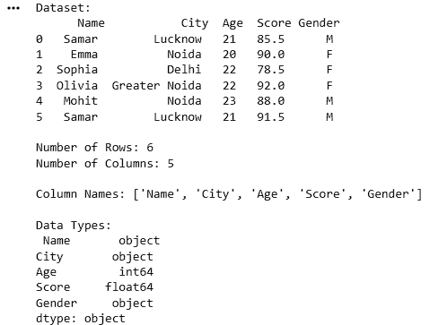
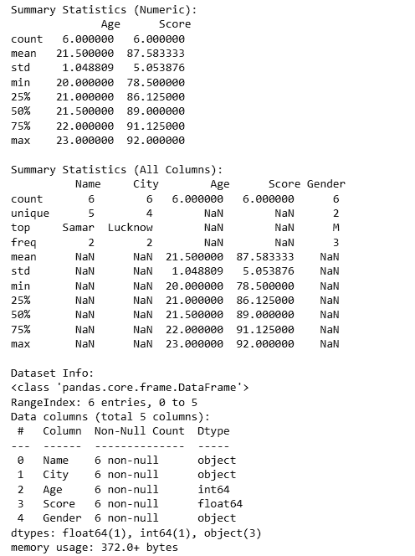

QUESTION 2
Given a dataset with missing values, implement techniques to handle missing data.
PROGRAM CODE
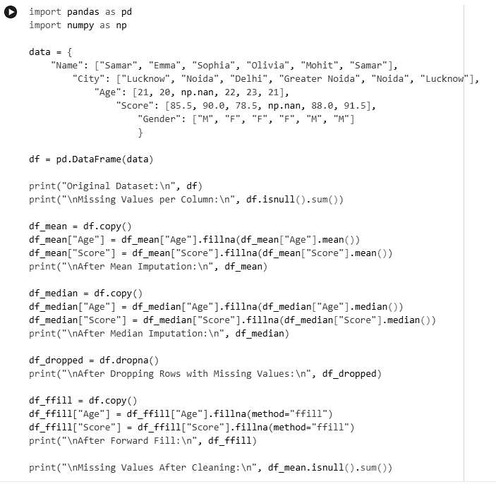

OUTPUT
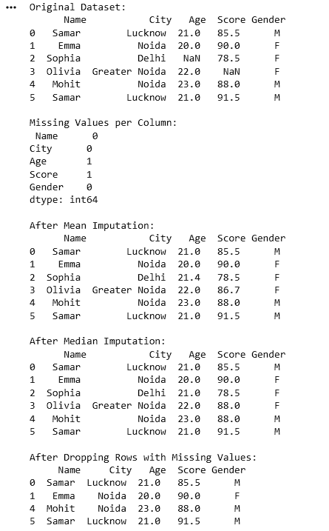
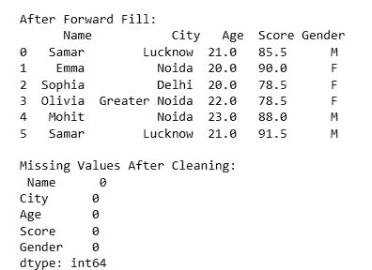

QUESTION 3
Convert categorical features into numerical format using appropriate encoding techniques.
PROGRAM CODE
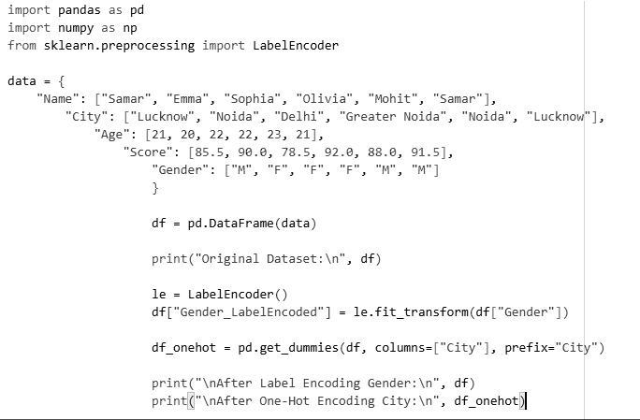
OUTPUT
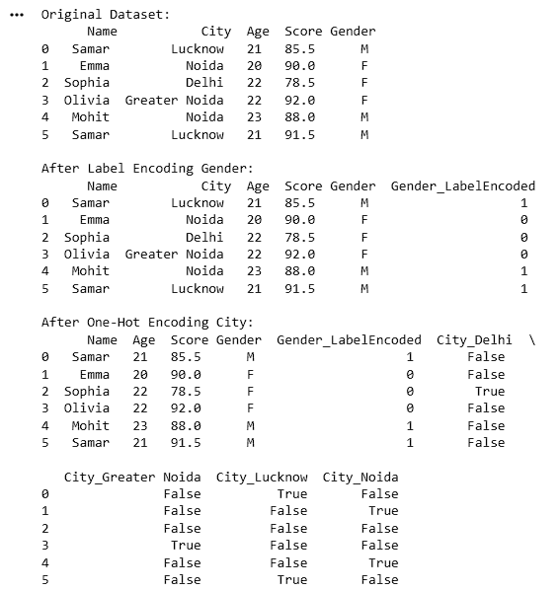

QUESTION 4
Apply normalization and standardization techniques on dataset features and compare the results.
PROGRAM CODE
01 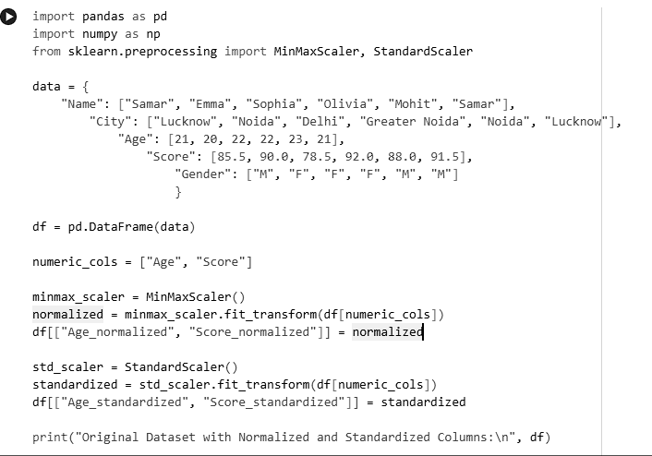
OUTPUT
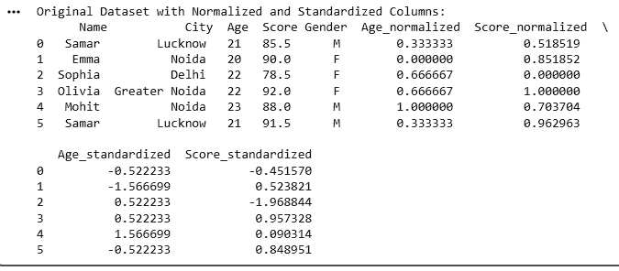

QUESTION 5
Detect and remove outliers from a dataset using statistical methods and visualize the results.
PROGRAM CODE
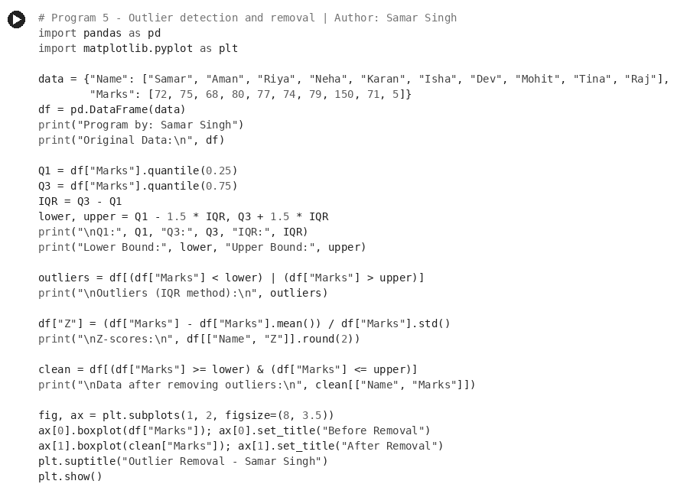
OUTPUT
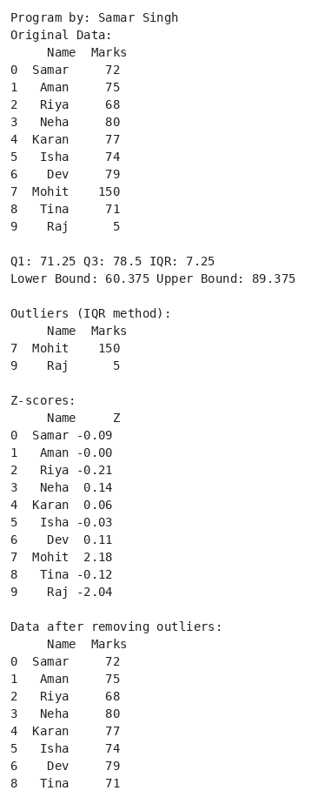
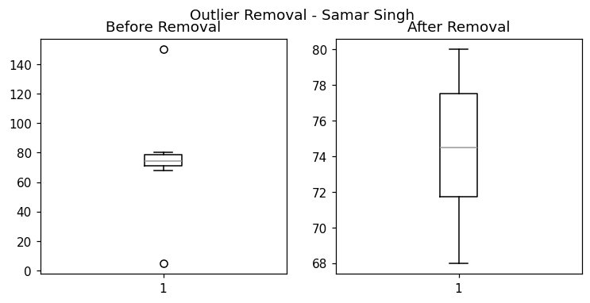

QUESTION 6
Select important features from a dataset using suitable feature selection techniques.
PROGRAM CODE
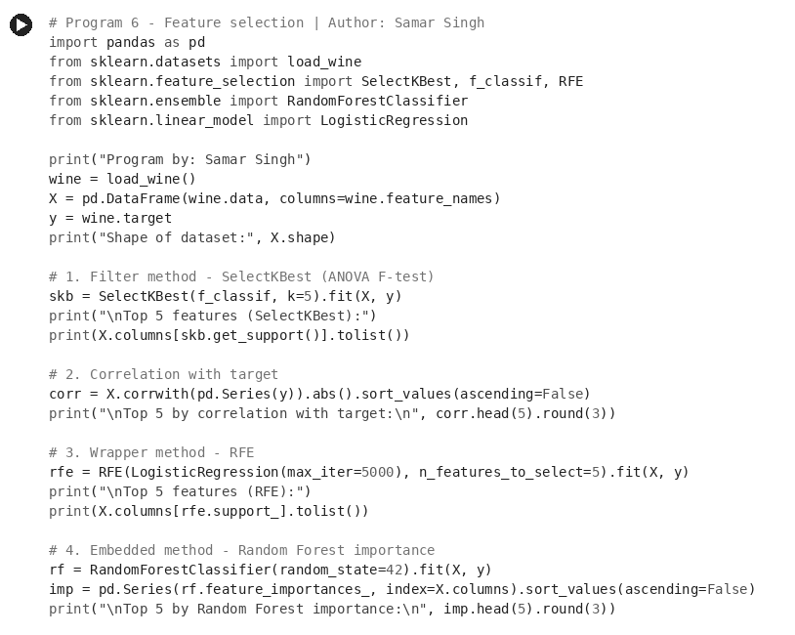
OUTPUT
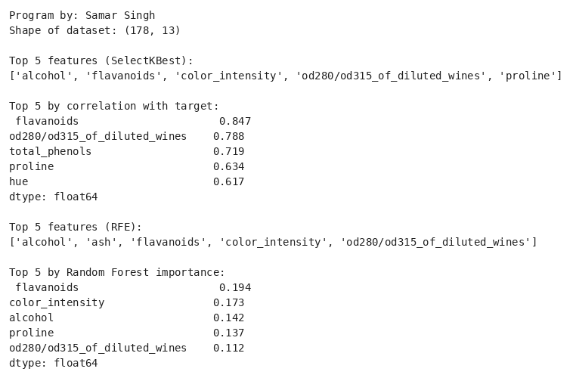

QUESTION 7
Reduce dimensionality of a dataset using Principal Component Analysis (PCA) and analyze the variance retained.
PROGRAM CODE
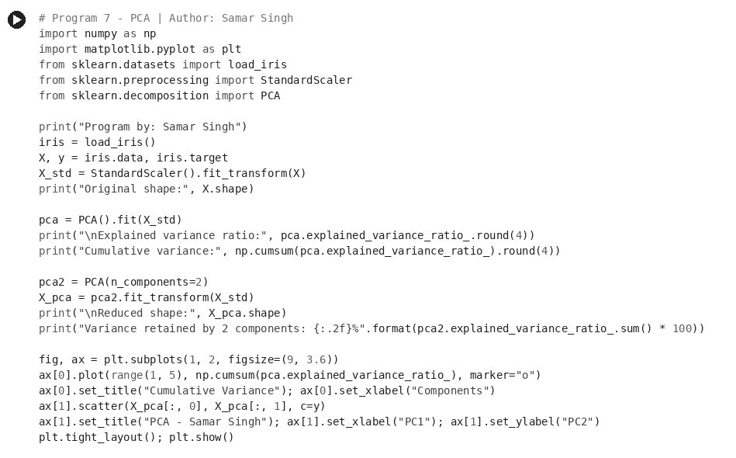
OUTPUT
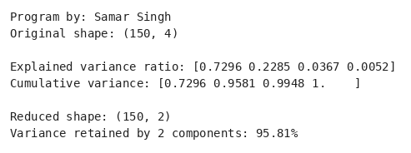
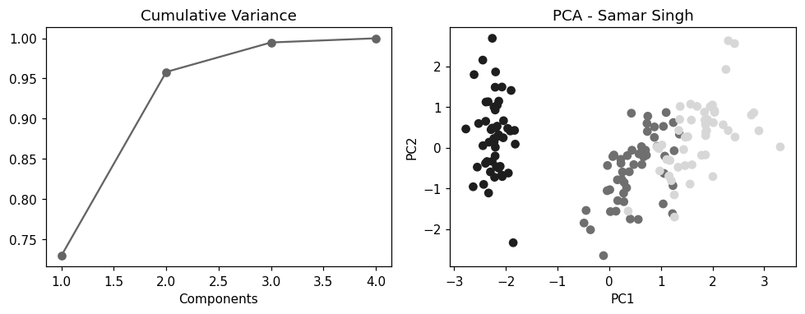

QUESTION 8
Implement simple linear regression on a dataset and predict the output variable.
PROGRAM CODE
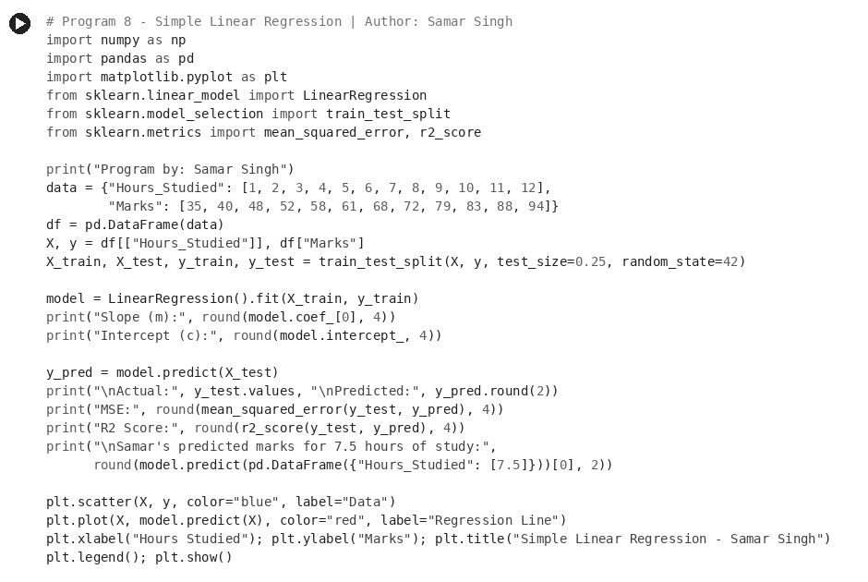
OUTPUT
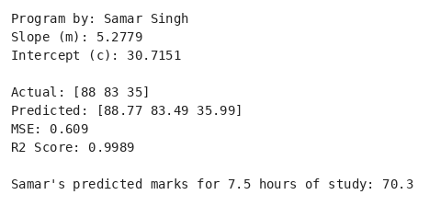
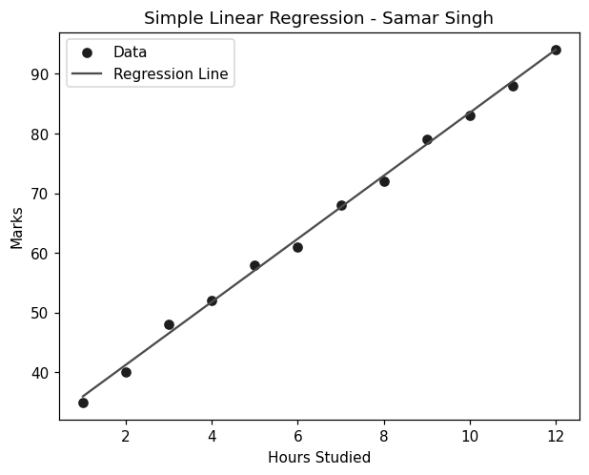

QUESTION 9
Build a multiple regression model using multiple input features and evaluate its performance.
PROGRAM CODE
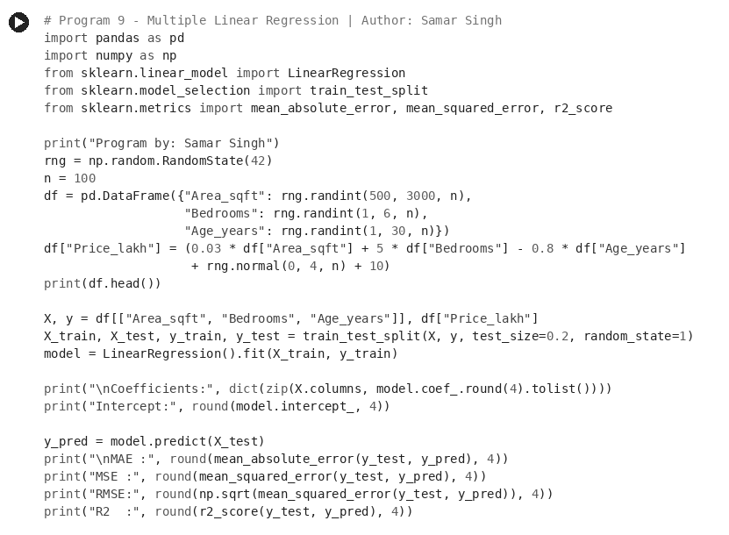
OUTPUT
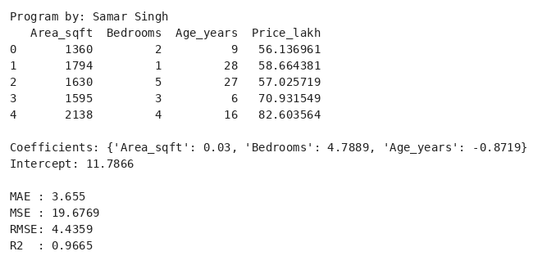

QUESTION 10
Implement binary classification using logistic regression and evaluate model accuracy.
PROGRAM CODE
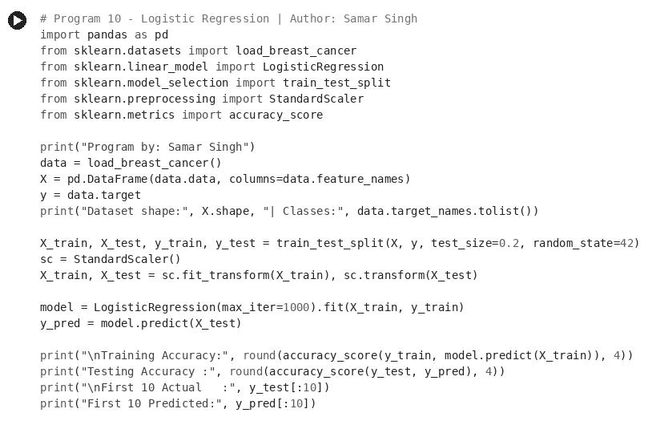
OUTPUT
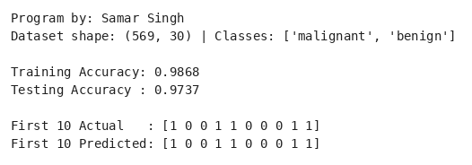

QUESTION 11
Evaluate the performance of a classification model using confusion matrix, precision, recall, and F1-score.
PROGRAM CODE
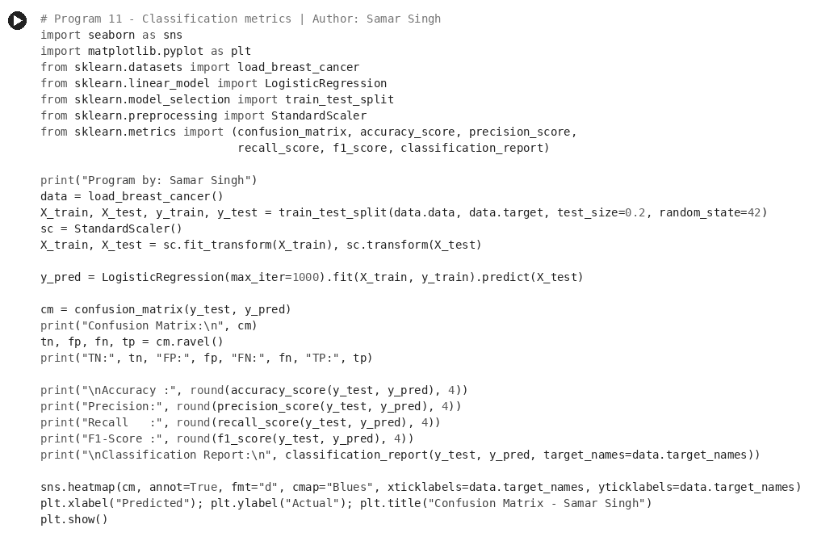
OUTPUT
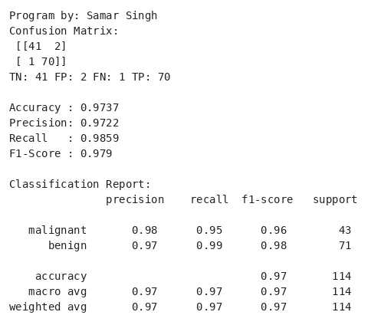
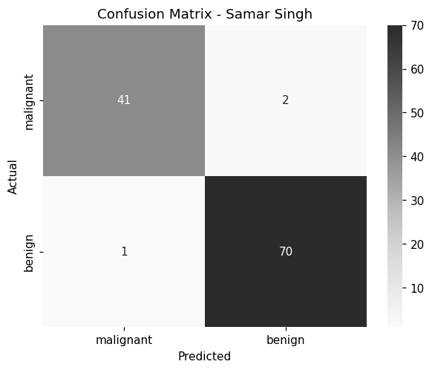

QUESTION 12
Implement k-Nearest Neighbors (k-NN) algorithm for classification and analyze the effect of different values of K.
PROGRAM CODE
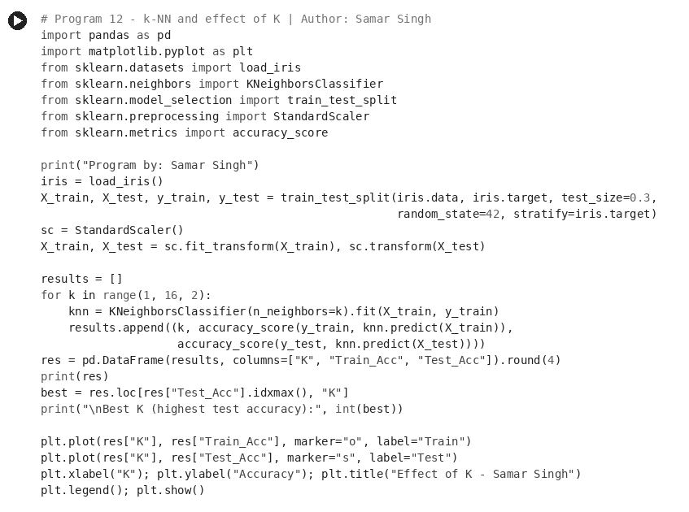
OUTPUT
